**StatefulSet:**

* Statefulsets are to maintain the stateful applications where it stores the state or data of an application.

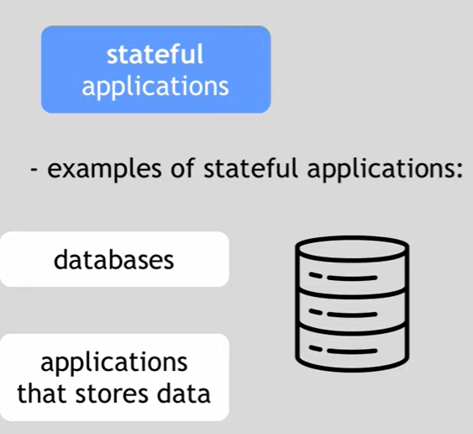

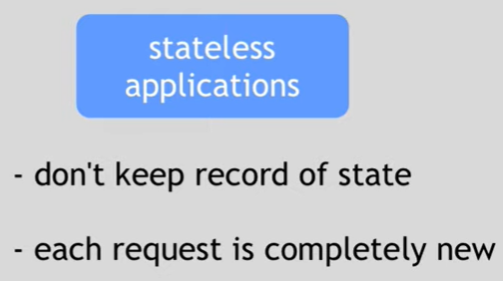

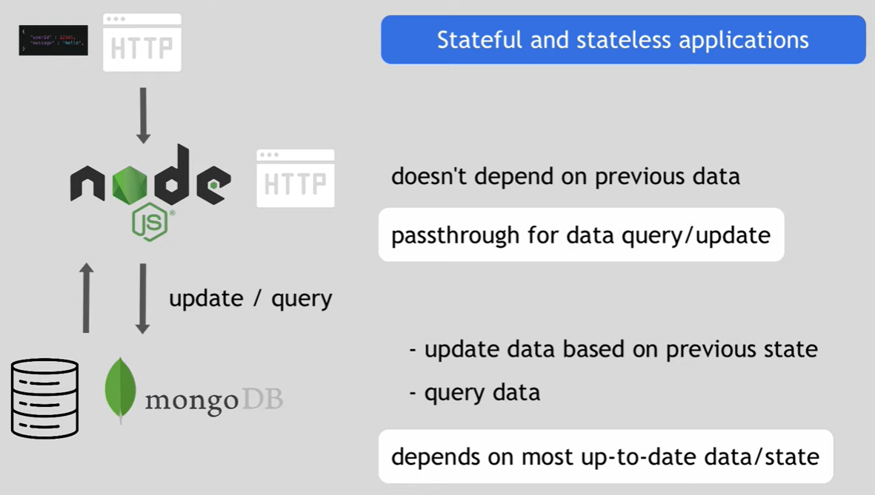

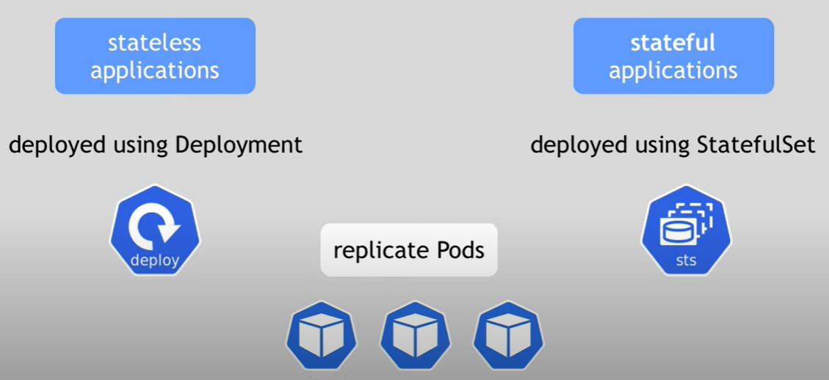

* Statefulsets can also replicate the pods.
* It also configures the storage equally.

**Deployment vs statefulset:**

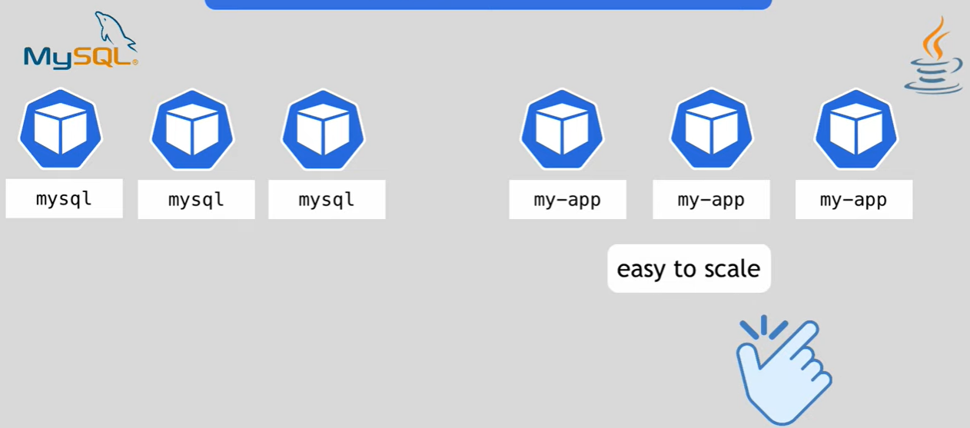

* Let’s say we have mySQL database deployed with statefulsets and java pods in deployments.
* Scaling up the java pods is pretty easy. It creates pods with random names and the service will load balance to the pods.
* And when we scale down the pods. One of the pods will be removed in deployment.

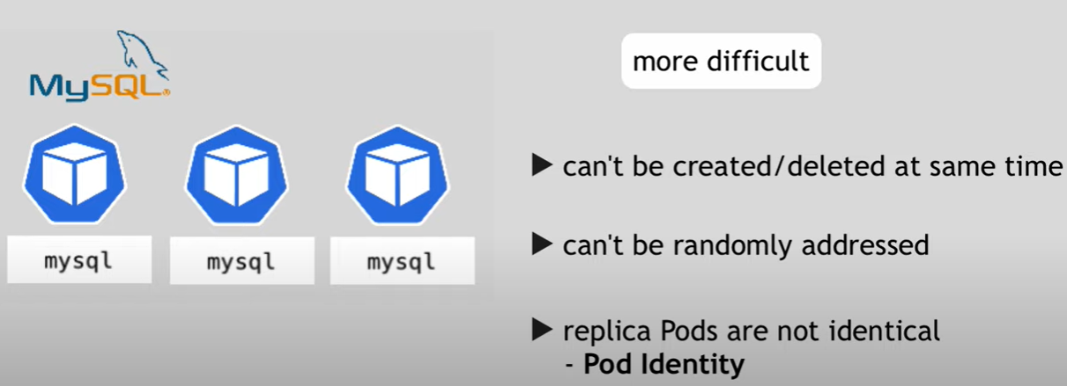

* But in statefulset, the pods can’t be deleted at same time.
* Here, it maintains the same identity for each pod.

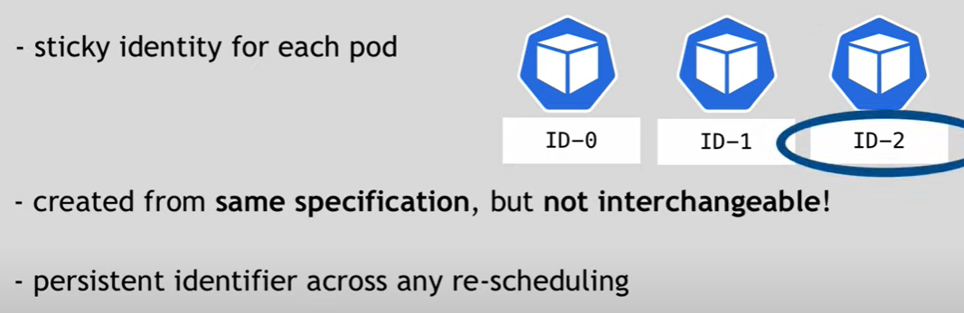

* If a POD dies here, it keeps the new pod with same identity.

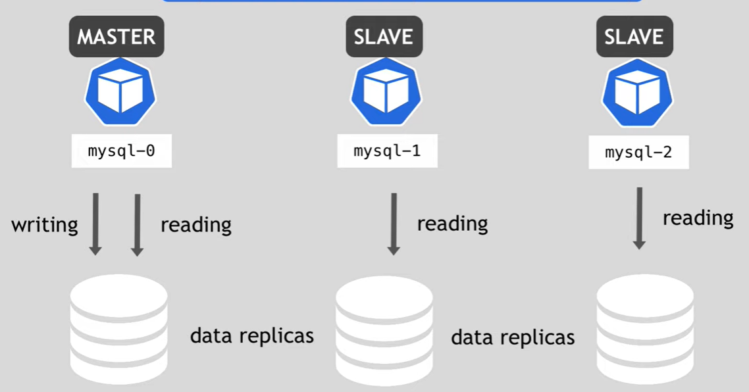

* In replicaset, it creates the replica of a POD where data will be identical.
* But the writing happens only from the main POD. Others are just to read the data.

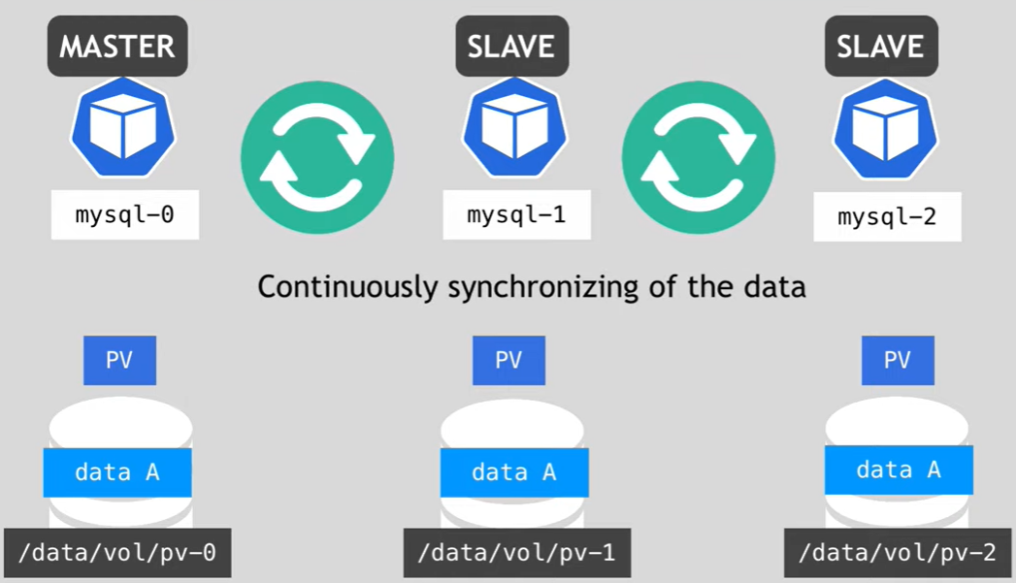

* Even though the PODS are replicated with each other. They are not using the same volumes.
* Master changes the data and all the slaves get updated data in sync to make sure each POD have same data.
* If we have mysql-0, 1, 2 PODs running and if new pod gets created with mysql-3 pod. It takes the data only from mysql-2 POD not from any other POD.
* But the data will be lost once all the PODs die.
* So, if we use PV then we can have the data saved even the POD dies.

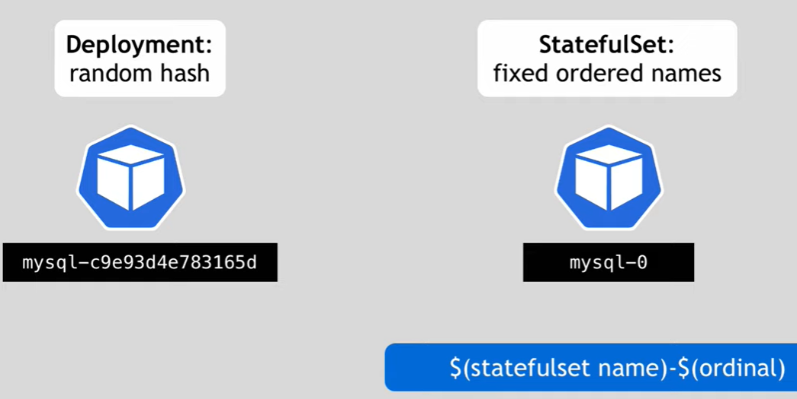

* Statefulset creates next new pod only if the previous one is up and running.
* Even when we delete, it does from the end. If the last one is deleted, then only it goes to the previous one.

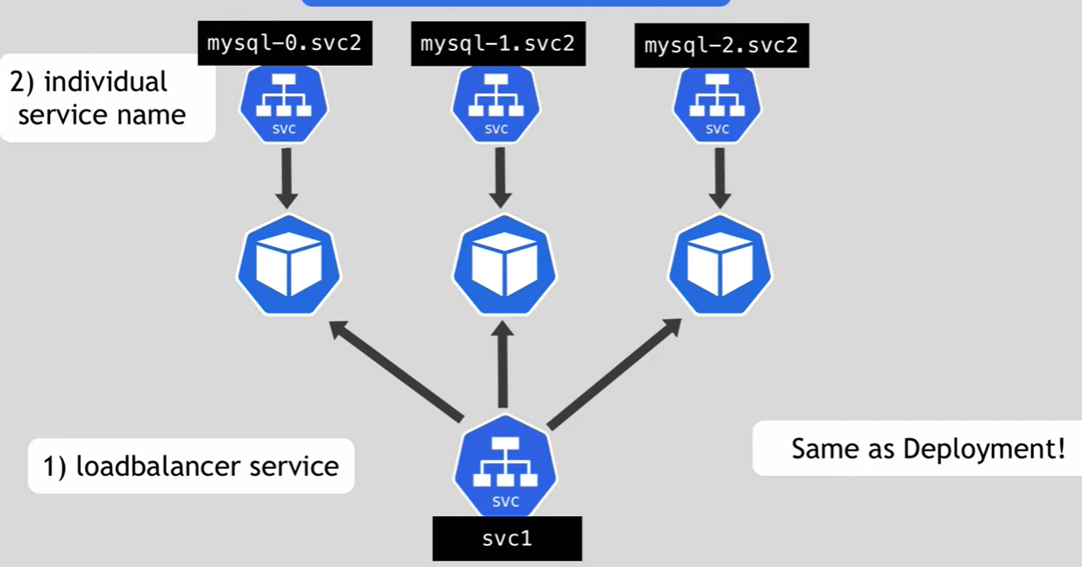

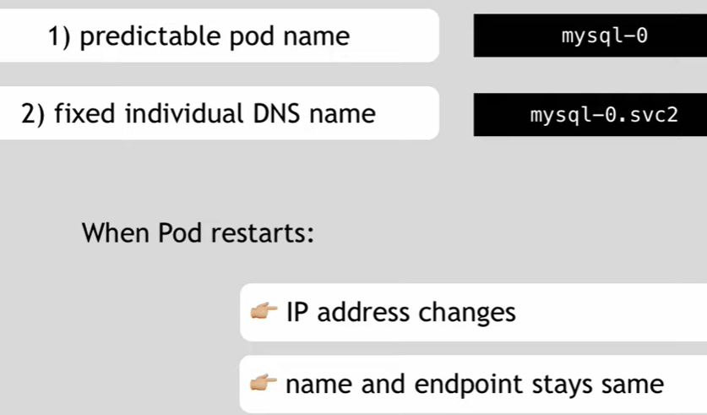

**Manifest file:**

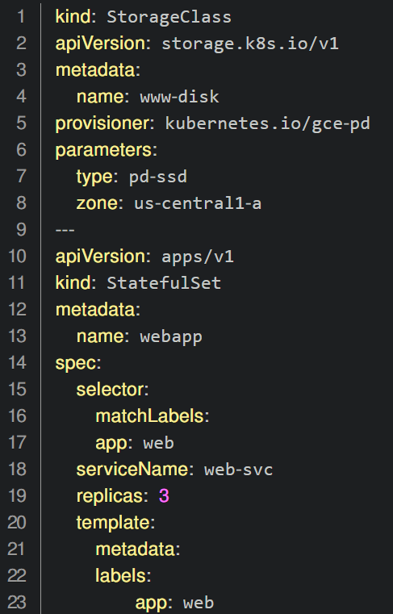

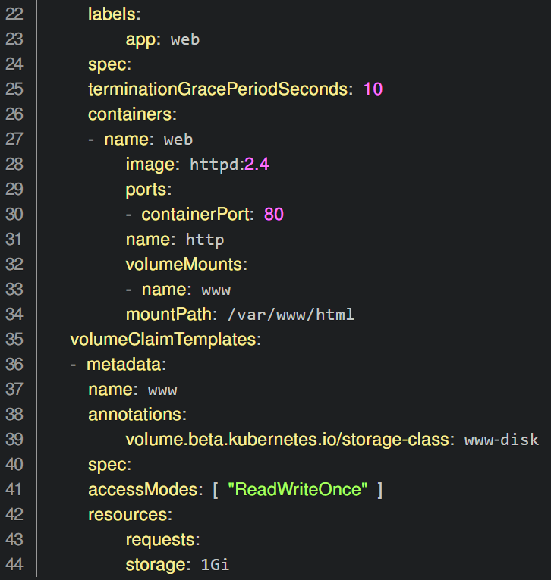

**Creation:**

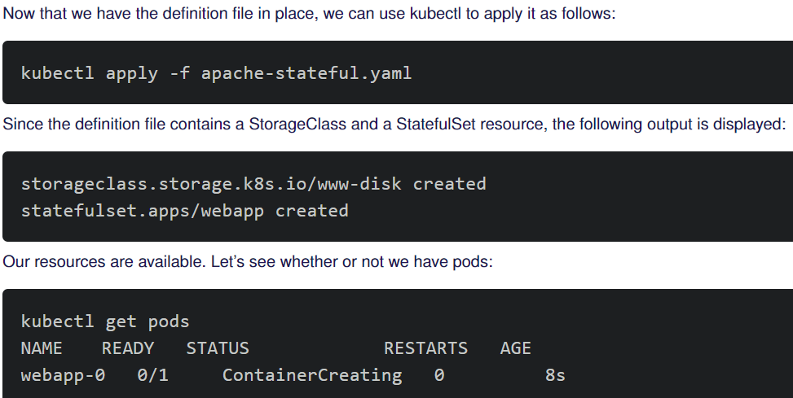

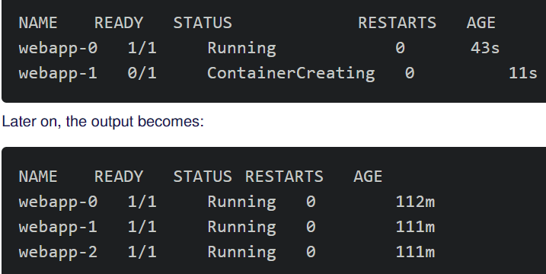

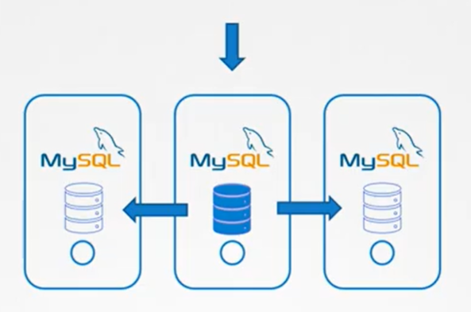

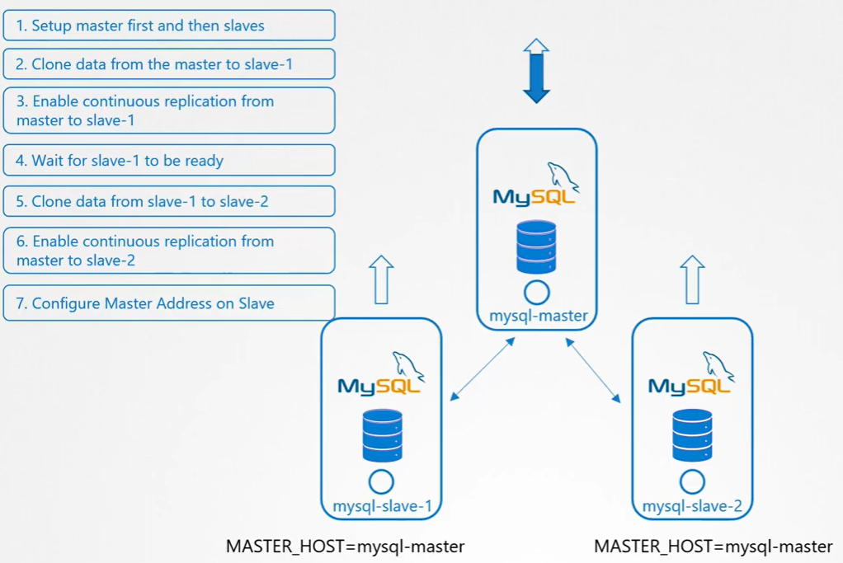

Let’s say we have a master database and clone the database into two slaves as above.

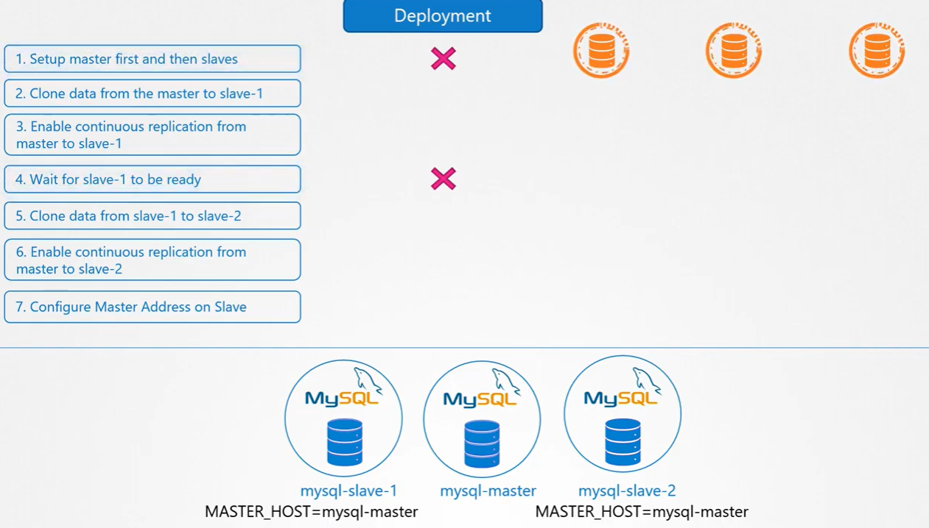

We can’t do the above steps with the deployment.

With deployment, PODS come up with new names.

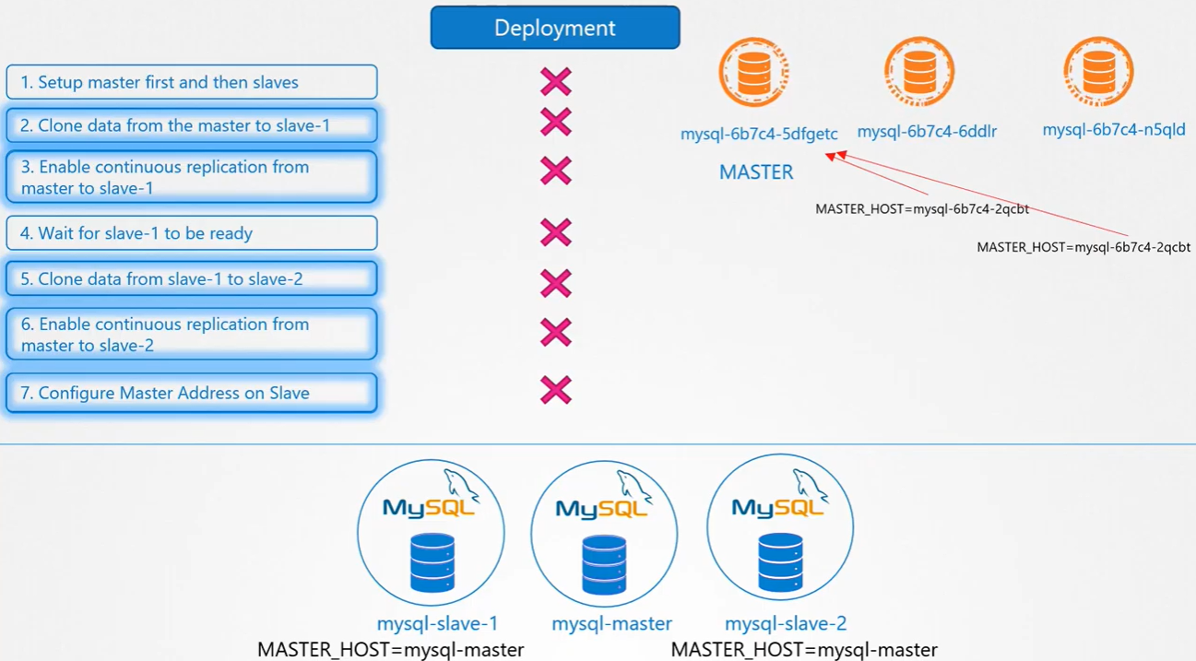

Statefulsets are similar to deployments

They can scale up/scale down, we can do rolling updates etc.

With statefulset, pods get created in an order.

Once the first pod is deployed and in ready or running state. Then the second pod will be deployed.

It starts with 0 and will be incremental.

